
Name of the Experiement : SHA-256 in Action – Cryptographic Hashing
Coding Phase : Pseudo Code/Flow Chart/Algorithm
• Start the program or open the hash tool

• Input a string or message

• Use the SHA-256 algorithm to convert the message into a hash

• Display the hash

• Change the input message slightly

• Hash again and compare with the previous hash

• End

Apparatus/Software Used:

- Online SHA-256 Tool
- Brave browser
- Internet Connection

Testing Phase:

Test case1:
Input :-hii...I am rashmi
Hase: 588dfbad6bcdcbd75a6bd431dd216f688943a15b0ff683a5ff3211a5e6c15d80 Test case 2:
Input : Hellow...I am rashmi
Hase : 099e9929306037759df60ab76d97762aabd28f3a7d3871557631837200fb2d44
Implementation Phase: Final Output (no error)
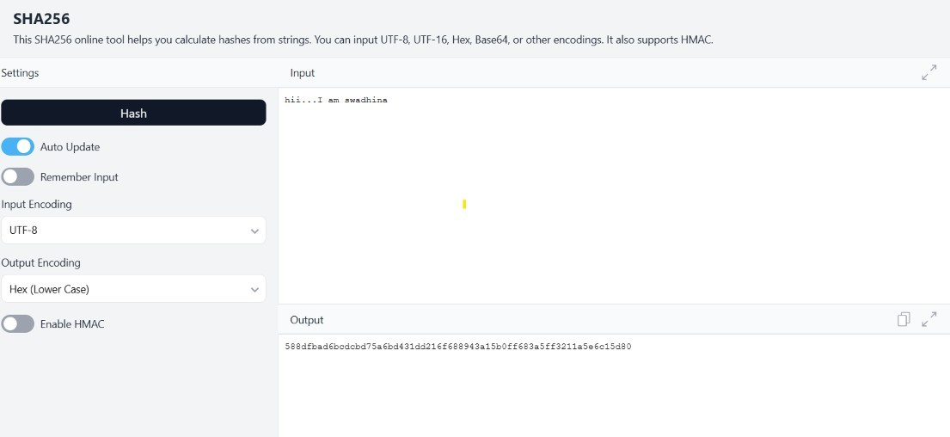
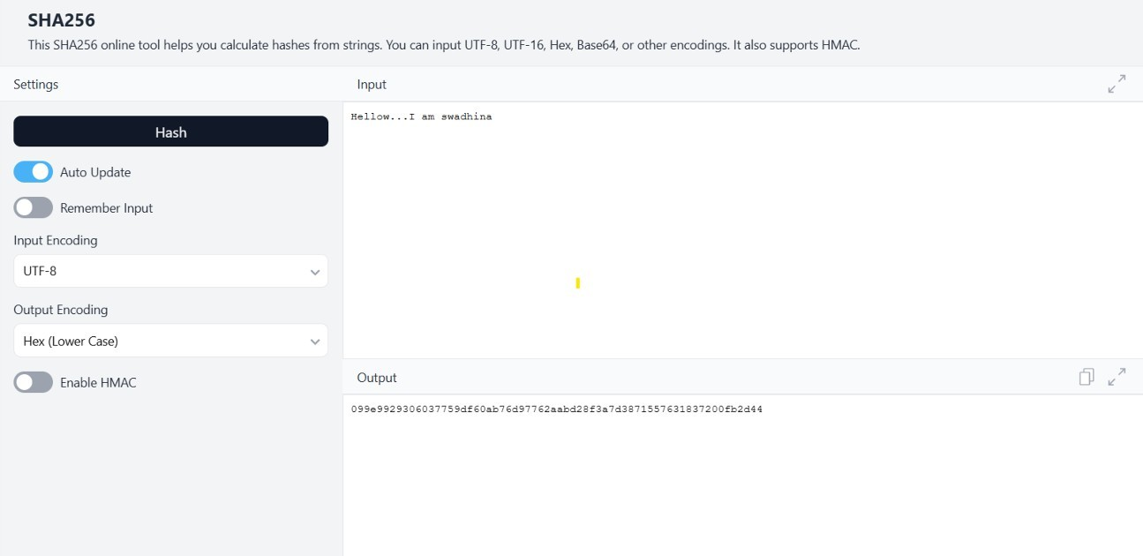
Using Online Tool
- Open SHA-256 Tool: https://emn178.github.io/online-tools/sha256.html
- Type any message
- Output hash is shown immediately Test case 1:

Test case 2:

Observations

• SHA-256 always gives a fixed 64-character hash.

• A minor change in input gives a completely different output.

• It is a one-way function — original data can’t be reversed.

• Commonly used in blockchains, digital signatures, file verification, and password storage.

• Highly secure, fast, and deterministic

